BALLYHOGUE RACECOURSE
Aintree racecourse;Ascot;Ayr;Bangor;Bath;Beverley;Brighton;Carlisle;Cartmel;Catterick;Cheltenham Festival;Chepstow;Chester;Doncaster St Leger;Epsom Derby;Exeter racecourse;Fakenham;Folkestone;Fontwell Park;Glorious Goodwood;Hamilton Park;Haydock Park;Hereford Racecourse;Hexham;Huntingdon;Kelso;Kempton Park;Leicester;Lingfield;Ludlow;Market Rasen;Musselburgh;Newbury Racecourse;Newcastle;Newmarket;Newton Abbot;Nottingham;Perth;Plumpton;Pontefract Racecourse;Redcar;Ripon;Salisbury;Sandown Park;Sedgefield;Southwell;Stratford;Taunton;Thirsk;Towcester;Uttoxeter;Warwick;Wetherby;Wincanton;Windsor;Wolverhampton;Worcester;Yarmouth;York Ebor
The tiny County Wexford village of Ballyhogue is located north east of Wexford and south of Enniscorthy. In the early 19th century it held its own races, although they were of minor significance and not widely publicised. However, the Irish Calendar of 1817 made reference to a meeting held in June 1817 when the village sought to ensure that races were staged with decorum. Horses were summoned to the post by a bugle and, once there, a red flag was hoist up the starting post so that the crowd knew the start of the race was imminent. Furthermore, their rules stated ’No jockey will be allowed to ride who is not dressed and equipped in a neat, sporting style’. While the results from their races have not stood the test of time, their desire to conduct their races in a professional manner lives on.
This racecourse is covered in Volume 4 of Racecourses Here Today and Gone Tomorrow. Ordering details shown below.
From 1815 onwards, and for many years afterwards, annual races were held at Ballyhogue which lasted all week and included weight-throwing, jumping and athletics.
Thomas Acres Ogle, born on 1st April 1780 at Logan Shade, Carne, County Wexford, described how he visited Ballyhogue racecourse as part of a campaign by the Irish Militia Office to recruit members. The races lasted all week and the Irish Militia were dressed in full uniform throughout in a bid to attract members to their ranks. They managed to sign up 17 stout young fellows, but 2 from Dublin and one from County Carlow deserted within a day. He remembers with great fondness, and much admiration, a fine young man named Moran, who showed a feat of athleticism never previously seen. The gateway to the racecourse at that time was a stone structure nine feet high and ten feet wide, which Moran managed to jump upon, make a half turn holding a stick, before jumping back down again. He seemed the ideal athlete to recruit to the militia, and they managed to sign him early in the week. Alas, on the last day of the races Moran gave the militia the slip and was never seen again.
During one of the many race meetings at Ballyhogue a prominent disgruntled owner withdrew his horse at the last minute from an important sweepstake race. In those days sweepstakes only went ahead if a certain number of runners took part, so by withdrawing his horse that minimum number of runners had been breached, and should have led to cancellation. However, a pedlar who happened to be present with his nag, offered to take part in the race, an offer which the landed gentry smugly and keenly accepted, because it meant that the race could continue, but it did not stop the noblemen from mocking the pedlar. Unbeknown to them, the pedlar and disgruntled owner of the withdrawn horse were in cahoots, the pedlar's horse, being a top steeplechaser, ran away with the race, enabling the pedlar and disgruntled owner to share the valuable prize.
The most famous horse to run at Ballyhogue was Old Spartacus who, in 1826, won the Painstown Stakes at Poorstown, worth £700, equivalent to day to £68,000, defeating a field of 16 others. He then went on to win the Cosby Stakes, worth £1600 (equivalent to £156,000 today), at the Heath of Maryborough racecourse, beating 18 other steeplechasers, before contesting a race at Ballyhogue. He won the first heat with ease, but broke down in the second heat, with injuries so severe that he never raced again.
The races were always good for the local economy, attracting people from far and wide, filling all local houses with paying guests, while many more stayed in Enniscorthy. At one particularly hot summer meeting a punter brought a bottle of 'refreshment' to the races with him and put it in the pond, adjacent to the water jump, to keep it cool. He probably enjoyed one too many beers and forgot all about his bottle. In the early 1900s the pond was being excavated and the lost bottle was found with cork still intact. The landowner took the bottle to his house, opened it at the end of dinner, and discovered the finest whiskey he had ever tasted.
Rumours abound that the old racecourse Grandstand was positioned next to a house owned by Jim and Brenda O'Brien, while the farm on which the steeplechases were held is owned by George Murphy and the Murphy family.
If you have photos, postcards, racecards. badges, newspaper cuttings or book references about the old course, or can provide a photo of how the ground on which the old racecourse stood looks today, then email johnwslusar@gmail.com
Much of the information about this course has been found using internet research and is in the public domain. However, useful research sources have been:-
London Illustrated News
Racing Illustrated 1895-1899
The Sporting & Dramatic Illustrated
Northern Turf History Volumes 1-4 by J.Fairfax-Blakeborough
The Sporting Magazine
A Long Time Gone by Chris Pitt first published in 1996 ISBN 0 900599 89 8
Racing Calendars which were first published in 1727

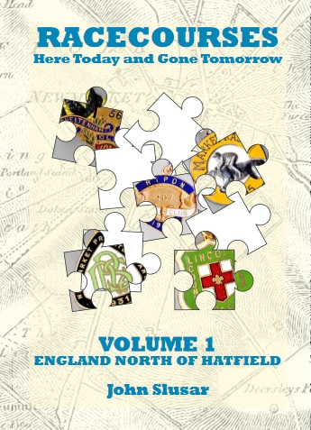 | 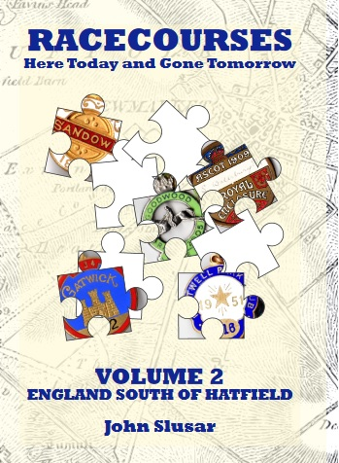 | 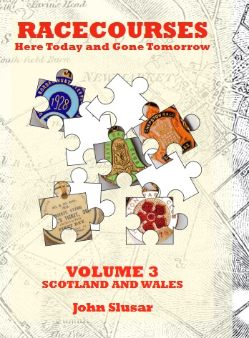 | 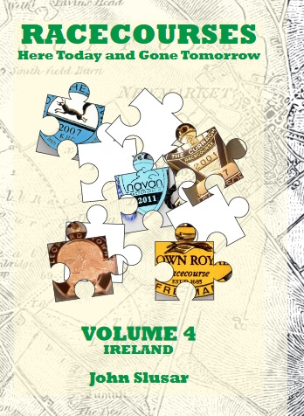
ISBN 978-0-9957632-0-3  652 pages  774 former courses | ISBN 978-0-9957632-1-0  352 pages  400 former courses | ISBN 978-0-9957632-2-7  180 pages  140 former courses | ISBN 978-0-9957632-3-4  264 pages  235 former courses
Copies of the above books are only available by emailing johnwslusar@gmail.com stating your requirements, method of payment (cheque payable to W.Slusar) or Bank transfer, and the address where the book(s) should be sent.
ORDER FORM
Download an order form
 | Quantity | Cost
Volume 1 North of Hatfield £19.99 + £4 postage
Volume 2 South of Hatfield £14.99 + £3 postage
Volume 3 Wales & Scotland £9.99 + £3 postage
Volume 4 Ireland £9.99 + £3 postage
Volumes 1 - 4 £54.96 + £5 postage
Postage & Packaging
Total
Email order form to johnwslusar@gmail.com

https://wexfordcivilwararchaeology.com/2019/02/06/the-burning-of-the-big-houses-wexfords-civil-war/
https://books.google.ie/books?id=WZABAAAAQAAJ&pg=PA85&lpg=PA85&dq=history+of+Ballyhogue&source=bl&ots=5A7nRKcKVG&sig=ACfU3U3NCwASt078JUeUK-83spW7k1DM-w&hl=en&sa=X&ved=2ahUKEwi92vPOl9rvAhU9QRUIHVZuCV84MhDoATACegQIAhAD#v=onepage&q=history%20of%20Ballyhogue&f=false

